SUMMER CAMP 2023
MONDAY 3  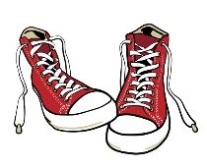  Ice Cream | TUESDAY 4  Honey Bee  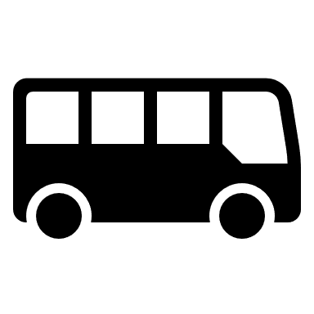 | WEDNESDAY 5  Beach | THURSDAY 6  Confederation Park | FRIDAY 7  Pizza day!  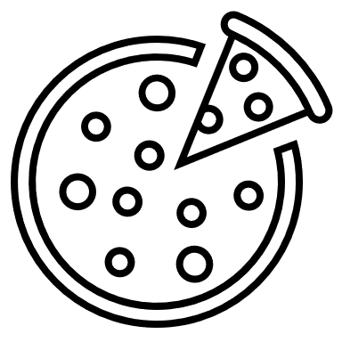
MONDAY 10  Science World | TUESDAY 11  Peter Rooke  Magician | WEDNESDAY 12  Stanley Park Beach/Water Park | THURSDAY 13  Beach Day | FRIDAY 14  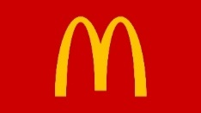  Magician
MONDAY 17  Bouncy Castle | TUESDAY 18  Grouse Mountain | WEDNESDAY 19 | THURSDAY 20  Jericho Beach | FRIDAY 21  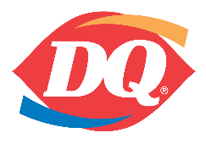
MONDAY 24  Mahon Water Park | TUESDAY 25 | WEDNESDAY 26  Pirate Adventures @ Granville Island | THURSDAY 27  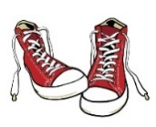  Clay Workshop | FRIDAY 28  Pizza day!  Peter Rooke
MONDAY 31  Art workshop | TUESDAY 1  Playland! | WEDNESDAY 2  Beach | THURSDAY 3  Cates Park | FRIDAY 4  Pizza day!  (Mc Donald’s anyone?)
MONDAY 7  CLOSED BC DAY | TUESDAY 8  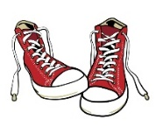  Karaoke | WEDNESDAY 9  Eagle Coaster | THURSDAY 10 | FRIDAY 11  PJ KIDS CLUB 42TH BIRTHDAY
MONDAY 14 | TUESDAY 15  Splash Water  Park | WEDNESDAY 16  Sports and games  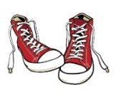  Bouncy Castle | THURSDAY 17  Granville Island Water Park | FRIDAY 18  Pizza day!
MONDAY 21  Vancouver Aquarium | TUESDAY 22 | WEDNESDAY 23  Rocky Point | THURSDAY 24 | FRIDAY 25  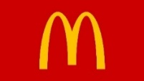  (Mc Donald’s anyone?)
MONDAY 28 | TUESDAY 29  Bowen Island | WEDNESDAY 30  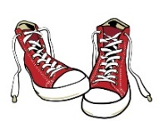 | THURSDAY 31  Bowling | FRIDAY 1  Magic Show

