SUMMER CAMP 2026
MONDAY 29  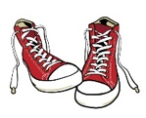  Bike Day | TUESDAY 30  Belcarra Beach    Metro Van. Workshop  “Curious Seashore Creatures” | Wednesday July 1  Canada Day    CLOSED | THURSDAY 2  Bike Day | FRIDAY 3  UBC Greenheart  Tree Walk
MONDAY 6  Sea to Sky Gondola | TUESDAY 7  Beach/Water Park   | WEDNESDAY 8  Bike Day | Thursday 9  Jericho Beach | FRIDAY 10  Bike Day
Monday 13  Britannia Mine  Museum | TUESDAY 14  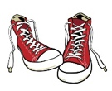  Bike Day | WEDNESDAY 15  Pacific Science Centre  Fisheries and Oceans | THURSDAY 16  Beach/Water Park | FRIDAY 17  Pizza Day!  
MONDAY 20  Beach/Water Park | TUESDAY 21  Capilano Suspension  Bridge | WEDNESDAY 22  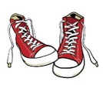  Bike Day | THURSDAY 23  Rocky Point Park | FRIDAY 24  Bouncy Castle
MONDAY 27  Grouse Mountain | TUESDAY 28  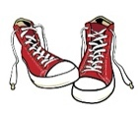  Bike Day | WEDNESDAY 29  Mahon Water Park | THURSDAY 30  Beach/Water Park | FRIDAY 31  Crazy Hair Day/  Pizza Day!
MONDAY 3  CLOSED BC DAY | TUESDAY 4  Stanley Park Waterpark | WEDNESDAY 5  Beach/Water Park | THURSDAY 6  Science World | FRIDAY 7  PJ KIDS CLUB 45th BIRTHDAY  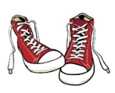  Bouncy Castle
MONDAY 10  Beach/Water Park | TUESDAY 11  H.R. MacMillian  Space Centre | WEDNESDAY 12  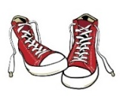  Bike Day | THURSDAY 13  Yorkson Park | FRIDAY 14  Pizza Day!
MONDAY 17  Air Extreme  Trampoline Park | TUESDAY 18  Bike Day | WEDNESDAY 19  Cates Park | THURSDAY 20  Beach/WaterPark | FRIDAY 21  Bike Day
MONDAY 24  Beach/Water Park | TUESDAY 25  Capilano Fish Hatchery  Metro Van. Workshop  “Big Friendly Forest” | WEDNESDAY 26  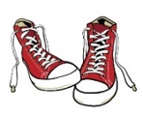  Bike Day | THURSDAY 27  Big Splash  Water Slide Park | FRIDAY 28  Pizza Day!
MONDAY 31  Beach/Water Park | TUESDAY 1  Bowen Island | WEDNESDAY 2  Bike Day | THURSDAY 3  Lions Park | FRIDAY 4  Bouncy Castle

