PJ KIDS CLUB
SPRING CAMP 2025
- Hours of operation are between 7:30 to 6:00 pm.
- Snacks are included.
- Schedule may change without notice due to weather conditions.

Monday 17th | Tuesday 18th | Wednesday 19th | Thursday 20th | Friday 21st
Bring your bikes!!!   | Crash Crawlies  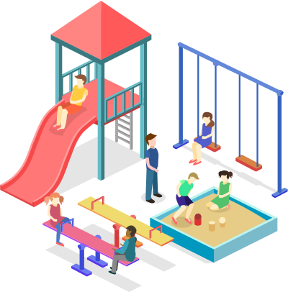  Booked | Art workshop  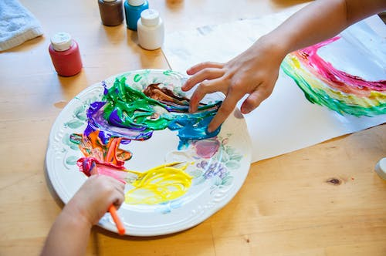 | Air Extreme Park   | Pizza lunch  Included  
Monday 24th | Tuesday 25th | Wednesday 26th | Thursday 27th | Friday 28th
6 pack Beach!  Richmond  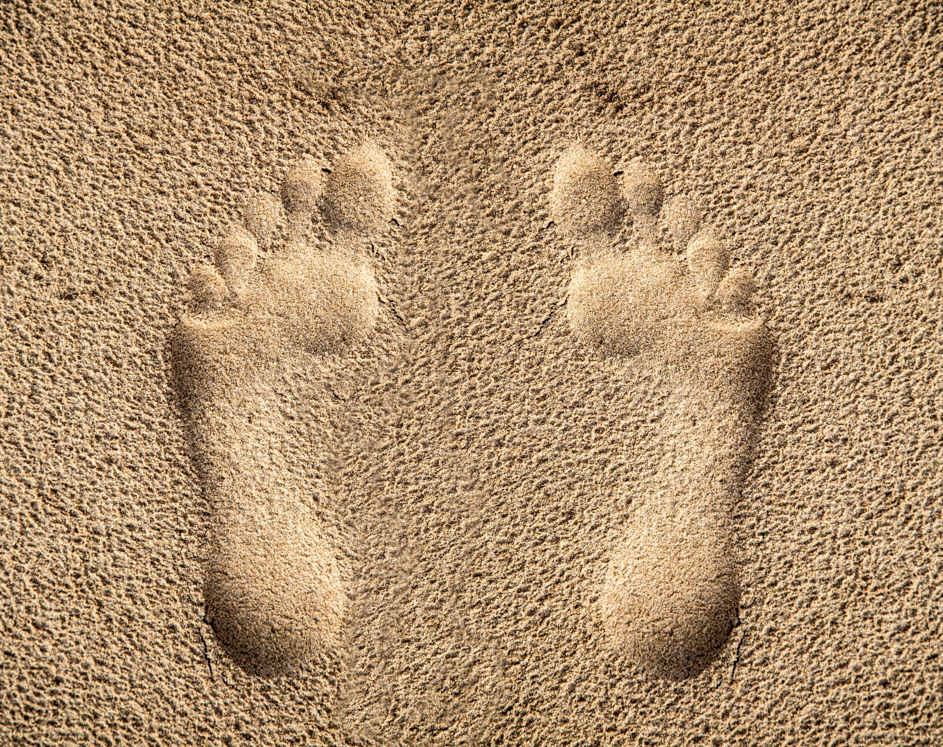 | Magician!   | Fly over Canada   | Bring your bikes!!! | Pizza lunch  Included

Registration form:
Child's name: _________________________________________Grade: __________________
Parent's name: __________________________________E-mail: _______________________
Address: ____________________________________________________________________
Phone number: _______________________________Cell:_____________________________

Monday, March 18TH | Tuesday March 19th | Wednesday March 20th | Thursday March 21st | Friday March 22nd
Monday, March 25th | Tuesday March 26th | Wednesday March 27th | Thursday March 28th | Friday March 29th  CLOSED

DAILY: TOTAL # DAYS: _____ X ($70) ______ += _______TOTAL:______
WEEKLY: TOTAL # WEEK 1 ($340) ____ Week 2 ($280) _______ TOTAL:______

TOTAL: __________________ + $50 Registration fee (if applicable) = _______________________

