Monday December 19th | Tuesday December 20th | Wednesday December 21st | Thursday December 22nd | Friday  December 23rd
Gingerbread houses  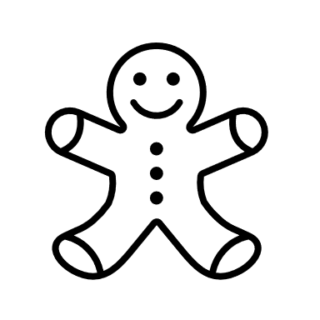 | Flying over Canada! | Winter Canvas Painting | Burnaby Village Museum | Merry Christmas!  Hot Chocolate and movie day!
WINTER BREAK AT PJ KIDS CLUB 2022
Welcome to our mini winter break schedule of activities. We have a fun filled week of entertainment for your children. Prices are $250 if your child is already registered on those days or $60 per day if your is not registered at PJ Kids Club.
NAME: ___________________________________________________________GRADE: ______
Parents name: ____________________________________Email: ________________________
Choose the days:
19 | 20 | 21 | 22 | 23

Number of days: ___________ (X $50) (X$60) = __________________
Annual Registration fee if applicable: $50.
TOTAL: _________________________________

- Please send your child with rain proof clothing, boots, hats, mittens, water bottle, snacks, and lunch.
- Payment is due at the time of registrations.
- No refund or cancellations after December 12th.
- KINDERGARTENERS QUALIFY FOR THE CHILD CARE FEE REDUCTION. PRICES WILL BE ADJUSTED ACCORDINGLY. (Starting December 1st 2022, Kindergarteners will receive further reductions)
