SUMMER CAMP 2024
MONDAY 1  Canada Day Closed  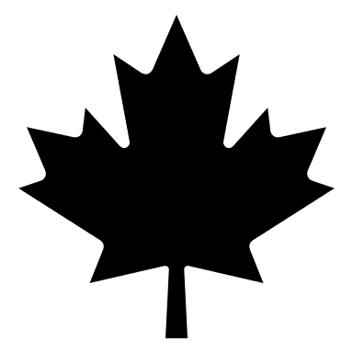 | TUESDAY 2 | WEDNESDAY 3  Britannia Mine Museum  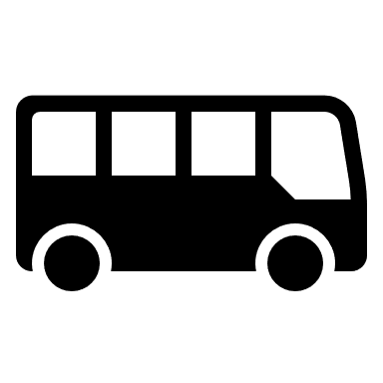 | THURSDAY 4  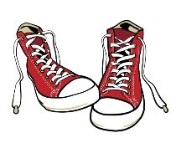 | FRIDAY 5  Playland
MONDAY 8  Pirate Adventures @ Granville Island | TUESDAY 9  Magician | WEDNESDAY 10  Stanley Park Beach/Water Park | THURSDAY 11  Beach Day | FRIDAY 12  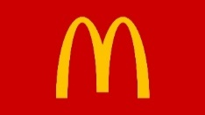
MONDAY 15  Bouncy Castle | TUESDAY 16  Splash Water  Park Tsawwassen | WEDNESDAY 17 | THURSDAY 18  Jericho Beach | FRIDAY 19  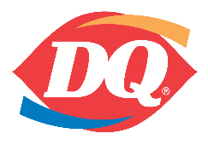
MONDAY 22  Cates Park | TUESDAY 23 | WEDNESDAY 24  Science World | THURSDAY 25  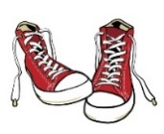  Clay Workshop | FRIDAY 26  Pizza day!  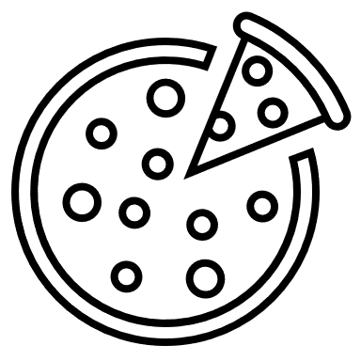
MONDAY 29  Art workshop | TUESDAY 30  Grouse Mountain | WEDNESDAY 31 | THURSDAY 1  Terranova Playground | FRIDAY 2  Pizza day!  (Mc Donald’s anyone?)
MONDAY 5  CLOSED BC DAY | TUESDAY 6 | WEDNESDAY 7  6 Pack Beach | THURSDAY 8 | FRIDAY 9  PJ KIDS CLUB 43rd BIRTHDAY
MONDAY 12 | TUESDAY 13  Sea To Sky Gondola | WEDNESDAY 14  Sports and games  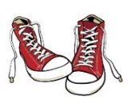  Bouncy Castle | THURSDAY 15  Mini Putt @ Seymour | FRIDAY 16  Pizza day!
MONDAY 19  Vancouver Aquarium | TUESDAY 20  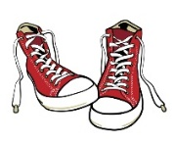 | WEDNESDAY 21  Rocky Point | THURSDAY 22 | FRIDAY 23  (Mc Donald’s anyone?)
MONDAY 26 | TUESDAY 27  Bowen Island | WEDNESDAY 28  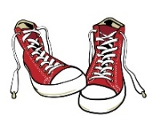 | THURSDAY 29  Bowling | FRIDAY 30  Magic Show

